|  |  |
| --- | --- |
| Name: | Holly Barry |
| Company: | Portfolio |
| Contact details: | [Holly.Barry@mail.bcu.ac.uk](mailto:Holly.Barry@mail.bcu.ac.uk) // [hollybarry@hotmail.co.uk](mailto:hollybarry@hotmail.co.uk) |

B r I e f :

I am wanting a portfolio website created for me so I am able to showcase my work to my future employers. I am a third year journalism student who also has a passion for design.

I currently have a portfolio website at the moment but I feel it doesn’t reflect me as a person and isn’t compatible with being able to view my journalism work in the best way. <http://www.hollybarry.portfoliobox.me/>

I have a logo already for myself which I would like to keep on the portfolio website somewhere.



Elements I am looking for in the website are:

* A page with my CV on – perhaps an option to be able to download it.
* Needs to have links to all my social media – Twitter: @journohol, Facebook page: Journohol, my Linkedin page: <https://uk.linkedin.com/in/hollyfrancesbarry> and my Wordpress blog: drummynews.wordpress.com
* A page with all my journalism work on – perhaps screenshot images of the articles themselves plus a link to go with it to read the full thing. It is vital that the link opens a new window. – could do it in a slideshow way.
* About me page with a picture of me
* Testimonal page which include all the things that have been said about me on placement. Could link to the website of the company/their logo etc.
* A page for my visual design work – this can be separated into different pages for each different piece of work for example, CD covers, magazines, posters and so on.
* I would like all the links going across the top of the page
* It needs to be bright, interesting but professional.
* Be creative with the layout – I am more attracted to something that is unique.

Colours I quite like:

* Yellow
* Pink
* Orange
* Lilac
* Minty blue

My design style:

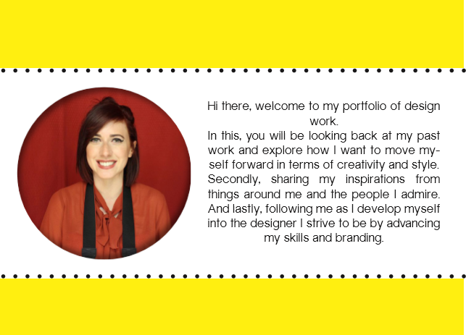

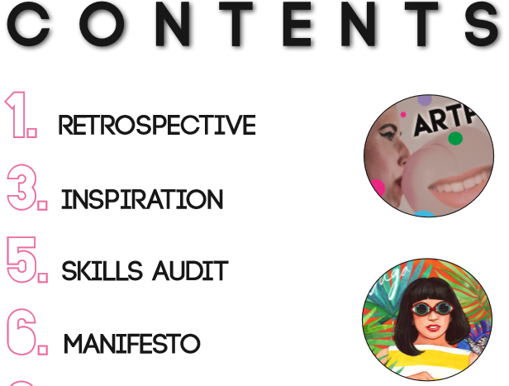

What I like in terms of design:

* Use of shape
* Dots & dashed lines
* Bold, thick font – Sans serif
* Simple but effective
* White backgrounds
* Lots of colour – not overboard though

C O N T E N T :

Journalism articles to include on the site:

I would prefer them to be spilt into categories such as The Scratch magazine, Birmingham Mail, Derby Telegraph, NUBI magazine, Birmingham Eastside. Or perhaps in genre of articles such as hard news, listicle, feature, opinion, review etc.

<http://scratch.media/2015/11/9-things-we-all-think-when-the-christmas-german-market-arrives-in-birmingham/>

<http://bournvillevillage.com/news/lidl-to-replace-stirchley-bowl/>

<http://birminghameastside.com/2015/10/28/birmingham-city-university-slams-council-work-as-not-up-to-standard/?isalt=0>

<http://www.buzzfeed.com/holista/things-that-happen-when-autumn-arrives-for-girls-1wpx7>

<http://www.bonafide-supernova.com/2015/09/review-lloyds-pharmacy-skin-effect-anti-ageing-serum/>

<http://scratch.media/2015/09/5-great-hair-products-for-under-a-fiver/>

<http://scratch.media/2015/09/holiday-review-lisbon-portugal/>

<http://scratch.media/2015/08/best-spot-treatments-that-actually-work/>

<http://www.bonafide-supernova.com/2015/08/autumnwinter-2015-make-up-trends-draft/>

<http://www.bonafide-supernova.com/2015/08/fleek-eyebrows-on-a-budget/>

<http://scratch.media/2015/08/the-big-hoot-announce-their-aunction-for-giant-owl-sculptures/>

<http://www.derbytelegraph.co.uk/USA-city-celebrates-Harry-Stevens-hot-dog-king/story-21161928-detail/story.html#ywvpiTlMAW1WARM8.01>

<http://scratch.media/2015/06/holiday-review-budapest/>

<https://hollybarry.atavist.com/lifeofaburnsurvivor>

<http://scratch.media/2015/04/teaminternet-how-youtubers-are-taking-the-media-by-storm/>

<http://birminghameastside.com/2015/04/07/5-cases-of-forced-marriage-reported-in-birmingham-since-legalisation/>

<http://birminghameastside.com/2015/03/27/education-needs-improving-says-all-major-political-parties/>

<http://birminghameastside.com/2015/03/16/founder-of-balls-to-cancer-urges-students-to-check-for-testicular-cancer/>

<http://birminghameastside.com/2015/03/10/birmingham-childrens-hospital-draws-up-plans-for-new-bereavement-suite/?isalt=0>

<http://birminghameastside.com/2015/02/23/st-johns-primary-school-holds-long-waiting-list/>

<https://drummynews.wordpress.com/2015/02/05/10-things-you-didnt-know-about-james-turner-street/>

<http://www.birminghammail.co.uk/news/midlands-news/1-jagerbomb-night-birmingham-club-8593186>

<http://www.birminghammail.co.uk/news/midlands-news/three-year-old-brain-injury-boy-stranded-8573933>

<http://www.derbytelegraph.co.uk/Youngsters-say-cheese-Baby-Year-competition/story-21169367-detail/story.html#X3OMh3mboyMcWpvM.01>

<http://scratch.media/2014/09/best-nights-voted/>

All my visual design work is on my old portfolio – you can save as all the images on there. If you require any of the images in better quality, you can email me at [hollybarry@hotmail.co.uk](mailto:hollybarry@hotmail.co.uk)

My testimonials & CV can also be found on my old portfolio page.

Image of myself to use:

